|  |  |
| --- | --- |
| **Case Study: Creating Analyses and Reports with SAS Visual Analytics for MegaCorp Dataset.** | |
| Name |  |
| Roll No |  |
| Class | B Tech EXTC Semester VI |
| Subject | Business Visualization |

Case study Scenario:-

You are an analyst at Megacorp, a toy manufacturing company. You were asked to explore the company data source to answer several; questions about data. During the case study you create several explorations and reports.

* **Megacorp Dataset**
* MegaCorp data source was created and needs to be located to the SAS LASR analytic server. Megacorp has several manufacturing facilities across United States. Each facility as one or more production units that produce the various products. In addition to the information about the facilities, units and products, the data source includes expenses, revenue and profit information. Base d on above information of Megacorp dataset design following explorations and Reports.
* **MegaCorp Exploration**
* **Create geo map visualization to explore the total capacity of each function unit in specific location.(create hierarchy for location)**

**Q1. Which facility in California has the lowest unit capacity?**

* **Create bubble plot to explore the relationship between unit yield and unit capacity by state. Assign Date by year to animation role.**

**Q2.Which state has the largest unit yeld and largest unit capacity?**

* **Create visualization to analyse the correlation between unit age and unit reliability**

**Q3. What is correlation value between unit reliability and unit age?**

* **Create visualization to analyse the correlation between unit age and expenses.**

**Q4. Based on the analysis are the majority of the units under or over five years?**

* **Create a visualization to analyse the average unit reliability and average unit yield rate for each month during the years 2007 through 2011.(use Line chart)**

**Q5. Which period of time has the largest unit yield ?**

**Q6. Which period of time has the smallest unit yield ?**

* **Create visualization to analyse profitability of each facility based on expenses, revenue and profit. Used hierarchy to create navigation path from region to state to city.(use bar chart)**

**Q7 which facilities in California have expenses that are largest then revenue?**

* **Create a visualization to analyse profit by year grouped by product line using line chart**
* **MegaCorp Report**
* **Create a report with two sections. The summary section displays expenses by product. The info window1 shows all the measures and includes several display rules. The dashboard should like below.**

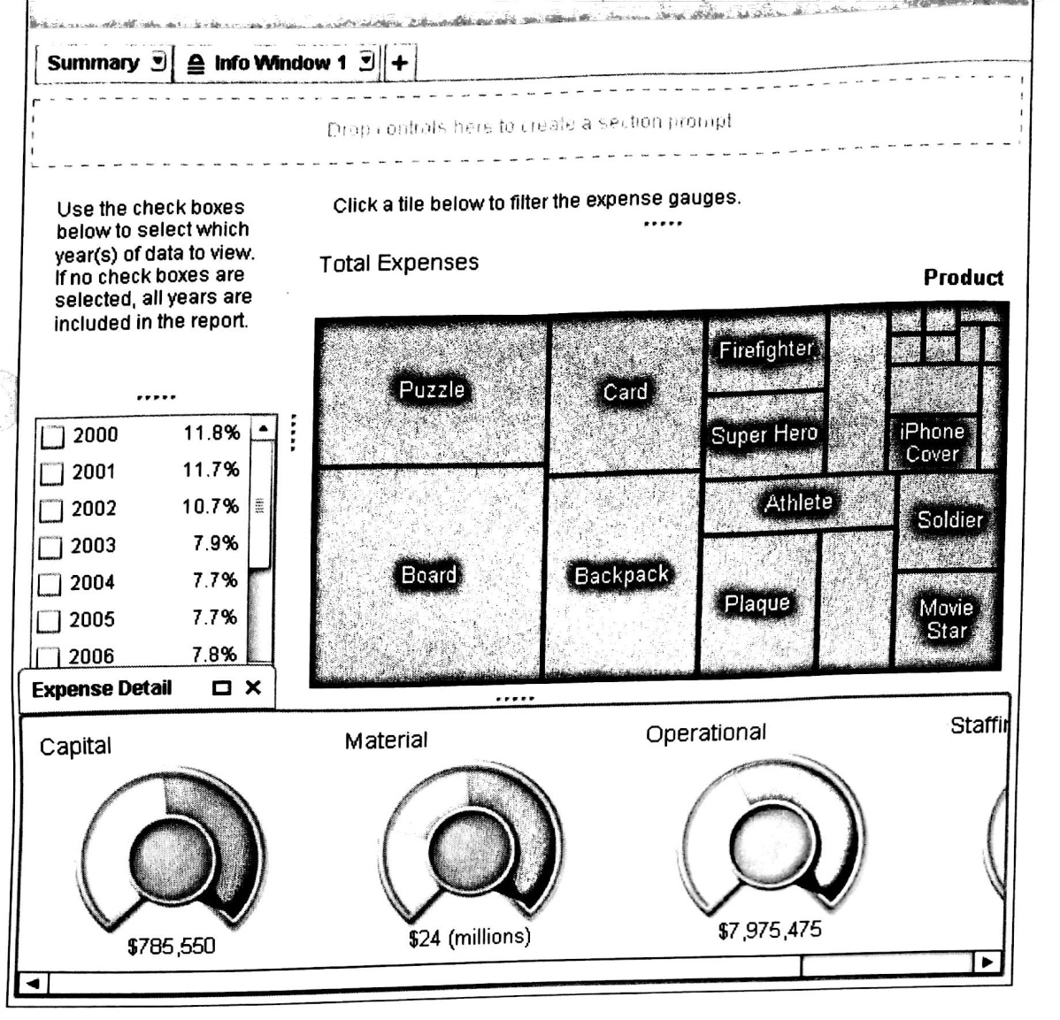

**The Dashboard should contain following objects**

1. **Info section should contain list table with following data item roles**

* **Product, expenses, revenue and profit.**
* **Add display rule to highlight if expenses are greater than profit.**
* **Add display rule to display icon in profit with low profit light green, medium profit faint green and high profit dark green.**

1. **Summary section should contain list table with following data item roles**

* **List table assign year and frequency percent as a role**
* **Tree Map Roles are**

**Tile=Product**

**Name =Expenses**

**Title=Total Expensed**

* **Add Horizontal Container and add four gauage controls**
* **First Gauage properties**

**Measure =Expenses(Capital)**

**Display rule**

**5000-37500 light blue**

**37500-75000 medium blue**

**75000-150000 dark blue**

**Name=Capital**

**Tile =Capital**

**Width =30**

**Type=Dial**

**DataSkin=Satin**

* **Second Gauage properties**

**Measure =Expenses(Material)**

**Display rule**

**55000-500000 light blue**

**500000-1000000 medium blue**

**1000000-2000000 dark blue**

**Name=Material**

**Tile =Material**

**Width =30**

**Type=Dial**

**DataSkin=Satin**

* **Third Gauage properties**

**Measure =Expenses(Operational)**

**Display rule**

**1 55000-225000 light blue**

**225000-450000 medium blue**

**450000-900000 dark blue**

**Name=Operational**

**Tile =Operational**

**Width =30**

**Type=Dial**

**DataSkin=Satin**

1. **Establish the interaction between the report objects.**